**P1 - Explain how HTML files access CSS**

**Introduction**

In this report, I will explain how HTML files is used to access cascading style sheet.

**Difference between HTML and CSS**

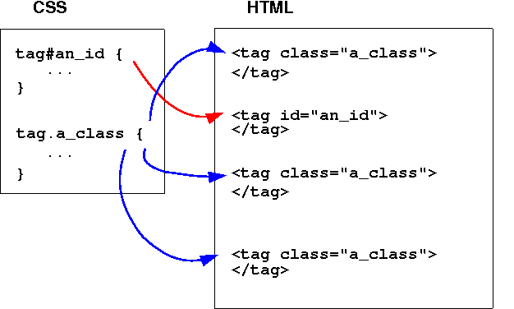Difference between HTML and CSS is that cascading style sheet is a content that enables web languages to use it. Hypertext mark-up language’s purpose is to give it a structure for the web page. It will sort everything out for you. The user can specify what he/she wants to do on the web page. CSS is added to the HTML coding to make everything easier. If a big company has a website, they would use CSS. To make it easier, some users can link the HTML document with the CSS document to make things easier too. The picture summarises how CSS works.

**Incline**

Incline is used within the head of the web page. These are HTML tags that uses CSS to enable the access being complete. To do this, incline uses the example below for this to be done. This is mainly done by typing in something similar in to be done. As you can see the example below, you can see the code that is imbedded in the HTML document to enable incline CSS to be complete. You can change the colour and the size by editing the code part,”colour: __” and “margin-left:__px;”.

**Example**

**<h1 style="color:blue;margin-left:30px;">This is a heading.</h1>**

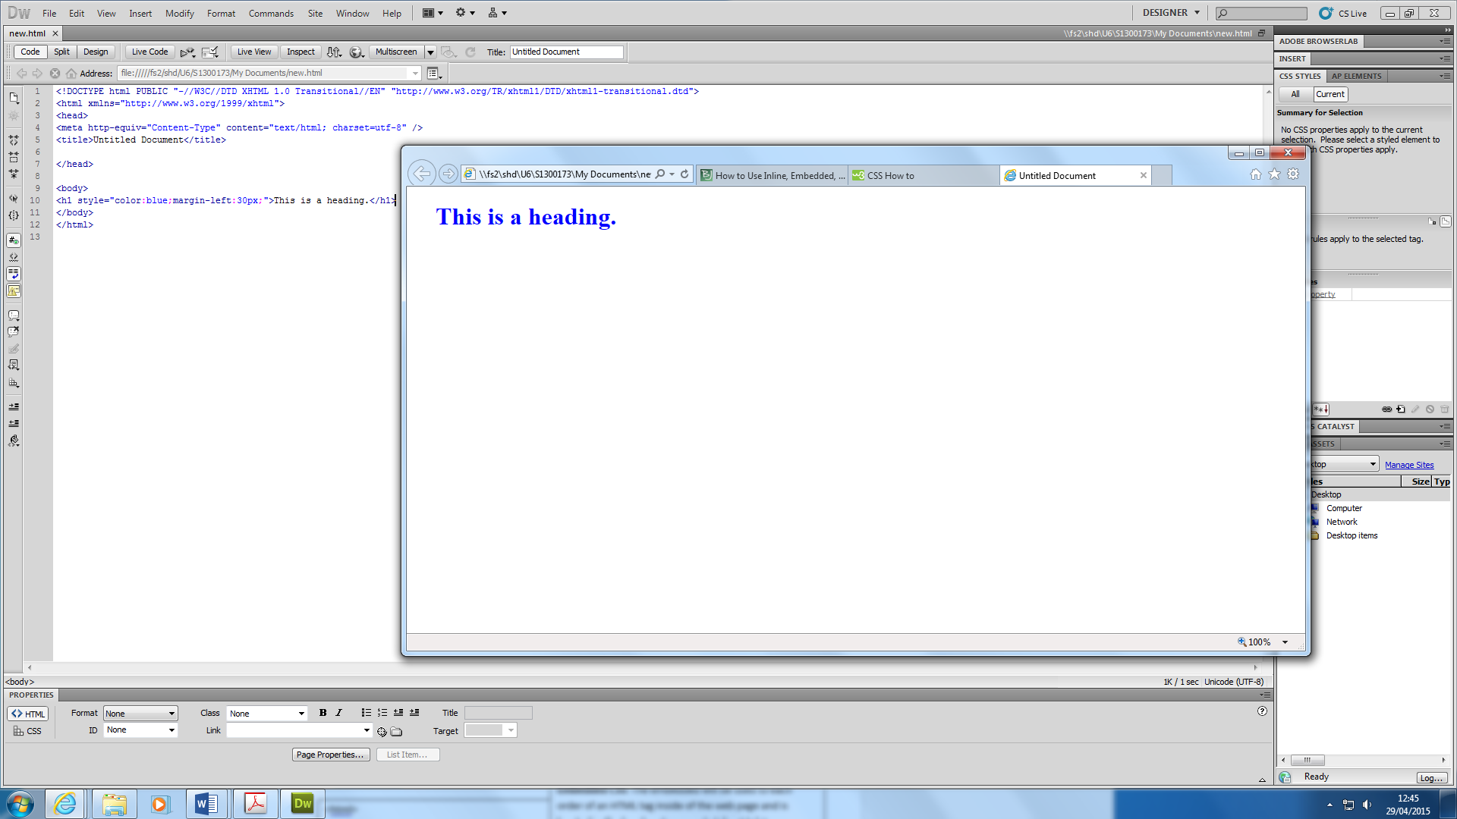

**Embedded**

Embedded styles are used mainly at the top of the web page. This is another tag that is located with the incline. However, it is separate. The difference between incline and embedded is that it goes below the incline as another heading, which it depended on what is written. An example is shown below of Embedded CSS of how it can be written within the link-up.

**Example**

**<style media="screen" type="text/css">**

**Add style rules here**

**</style>**

**External**

A style sheet can be saved by using “.css”, and it can be saved by saving it as, “myStyle.css”. An External CSS can be used to change the way the website looks by using only one code on the style sheet file. An example is shown below of how it can be changed.

**Example**

**<link rel="stylesheet" href="css/sitewide.css" type="text/css" />**

**M1 - Assess different implementation styles of CSS**

**Introduction**

In this report, I will explain the advantages and disadvantages of the different styles of CSS.

**Incline**

**Advantage**

* A external document is not needed for incline
* Loads faster
* It tests with internal CSS

**Disadvantage**

* Hard to fix an error
* Repeat of code
* File size increase

**Embedded**

**Advantage**

* Style the website more than incline
* Less HTTP requests

**Disadvantage**

* Multiple documents cannot be used for multiple web pages
* Slow the website down

**External**

**Advantage**

* File size is reduced
* Display of website
* Easy to work

**Disadvantage**

* It can be complicated to work with for a small website

**Reference**

* <http://www.differencebetween.net/technology/difference-between-html-and-css/>
* <http://www.boogiejack.com/CSS_3.html>
* <http://webdesign.about.com/cs/css/qt/tipcssatimport.htm>